|  |
| --- |
| Logo, company name  Description automatically generatedAIC, MATHEMATICS LEARNING AREA  **YEAR 11 MATHEMATICS APPLICATIONS – UNIT 2**  **Assessment type: Response**  **TASK 9 – TEST 6**  **Applications of trigonometry** |

MARKING KEY

**TIME ALLOWED FOR THIS PAPER**

**Reading and Working time for this paper: 50 minutes in class under test conditions**

**MATERIAL REQUIRED FOR THIS PAPER**

*TO BE PROVIDED BY THE SUPERVISOR*

Question/answer booklet.

*TO BE PROVIDED BY THE CANDIDATE*

*Standard Items:* pens, pencils, pencil sharpener, highlighter, eraser, ruler, drawing templates

**IMPORTANT NOTE TO CANDIDATES**

No other items may be taken into the examination room. It is **your** responsibility to ensure that you do not have any unauthorised notes or other items of a non-personal nature in the examination room. If you have any unauthorised material with you, hand it to the supervisor **before** reading any further.

**Structure of this paper**

|  |  |  |  |  |
| --- | --- | --- | --- | --- |
| Section | Number of questions available | Number of questions to be attempted | Suggested working time (minutes) | Marks available |
| **Calculator Assumed** | **7** | **7** | **50** | **42** |
|  | | | **Marks available:** | 42 |
| **Task Weighting** | 7% |

**Instructions to candidates**

* The rules for the conduct of this examination are detailed in the booklet *WACE* *Examinations Handbook*. Sitting this examination implies that you agree to abide by these rules.
* Answer the questions in the spaces provided.
* Spare answer pages can be used. If you need to use them, indicate in the original answer space where the answer is continued.

### SCSA Content – Topic 2.2: Applications of trigonometry

* + 1. Use trigonometric ratios to determine the length of an unknown side, or the size of an unknown angle in a right-angled triangle
    2. Determine the area of a triangle, given two sides and an included angle by using the rule $area=\frac{1}{2} absinC$, or given three sides by using Heron’s rule, and solve related practical problems
    3. Solve problems involving non-right-angled triangles using the sine rule (acute triangles only when determining the size of an angle) and the cosine rule
    4. Solve practical problems involving right-angled and non-right-angled triangles, including problems involving angles of elevation and depression and the use of bearings in navigation

**TO BE AWARDED FULL MARKS ALL WORKING OUT AND CALCULATIONS MUST BE SHOWN**

**Question 1 (4 marks)**

(a) 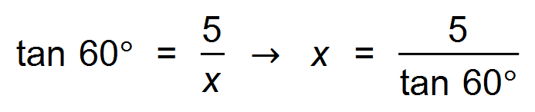 ✓

∴ *x* = 2.89 m ✓

(b) 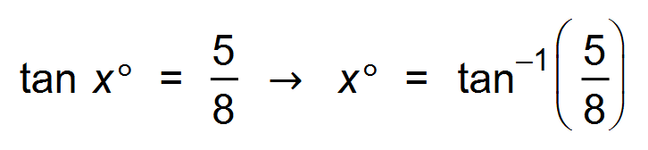 ✓

∴ *x* = 32.01° ✓

**Question 2 (3 marks)**

|  |
| --- |
| **Solution** |
| $$\tan{23}=\frac{38}{x}⇒x=89.5 \text{m}$$ |
| **Specific behaviours** |
| ✓ sketch diagram with measurements  ✓ uses tangent ratio  ✓ states distance |

**Question 3 (9 marks)**

(a) 208°T ✓✓

(b)

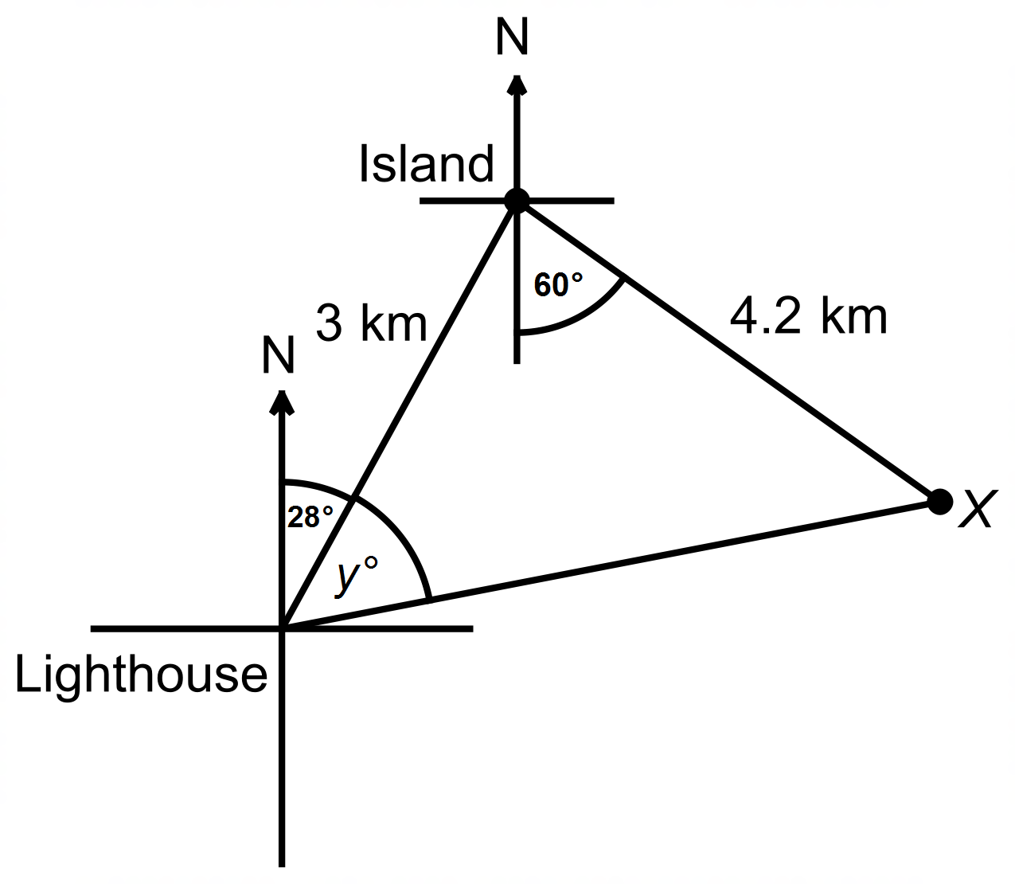

✓✓

(c) 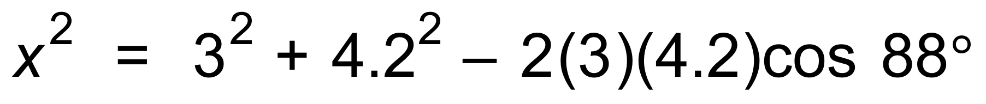 ✓✓

∴ x = 5.075 km

(d) 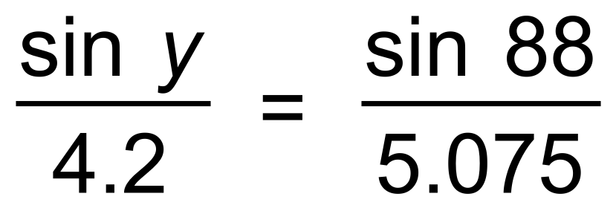 ✓

∴ *y* = 55.8° ✓

∴ Bearing is 56 + 28 = 084°T ✓

**Question 4 (7 marks)**

(a) 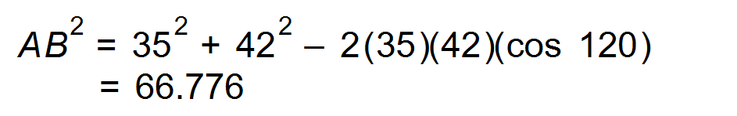 ✓✓

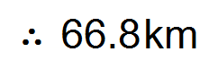 ✓

(b) 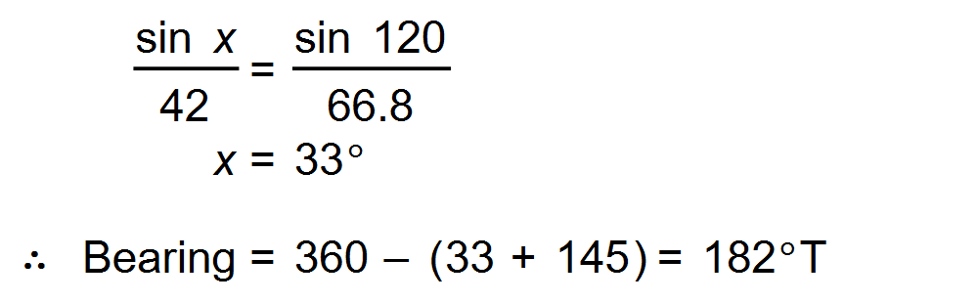 ✓✓

(c) 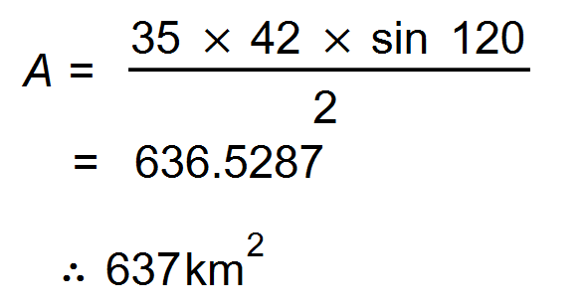 ✓✓ [7]

**Question 5 (7 marks)**

(a) 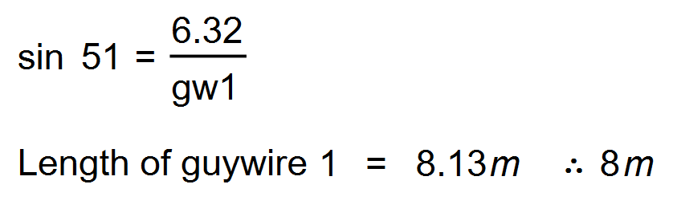 ✓✓

(b) 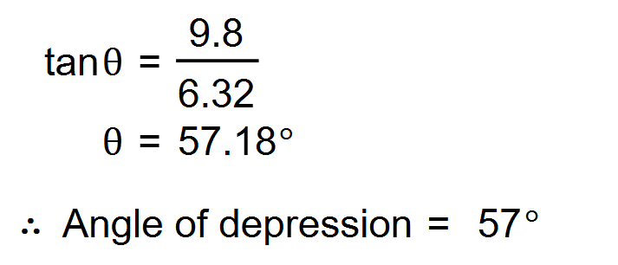 ✓✓ [4]

**Question 6 (8 marks)**

(a) Sketch a diagram to show the above information. (2 marks)

|  |
| --- |
| **Solution** |
|  |
| **Specific behaviours** |
| ✓ vertical $TB$ with angle of depression to $A$ ✓ lengths $TB$ and $BC$, making a right-angle |

(b) Calculate the line of sight distance from the top of the pole to $A$. (2 marks)

|  |
| --- |
| **Solution** |
| $$AT=6.4÷\sin{32} \\ =12.1 \text{m}$$ |
| **Specific behaviours** |
| ✓ uses sine ratio  ✓ correct distance |

(c) Determine the angle of depression from $T$ to $C$. (2 marks)

|  |
| --- |
| **Solution** |
| $$∠TCB=\tan^{-1}{\frac{6.4}{5.5}} \\ =49.3°$$ |
| **Specific behaviours** |
| ✓ uses tangent ratio  ✓ correct angle (to nearest degree) |

(d) Calculate the distance travelled by the animal from $A$ to $C$. (2 marks)

|  |
| --- |
| **Solution** |
| $$AB=6.4÷\tan{32}=10.2 \text{m}$$ $$AC=10.2-5.5=4.7 \text{m}$$ |
| **Specific behaviours** |
| ✓ calculates $AB$ ✓ calculates $AC$ |

**Question 7 (7 marks)**

(a) 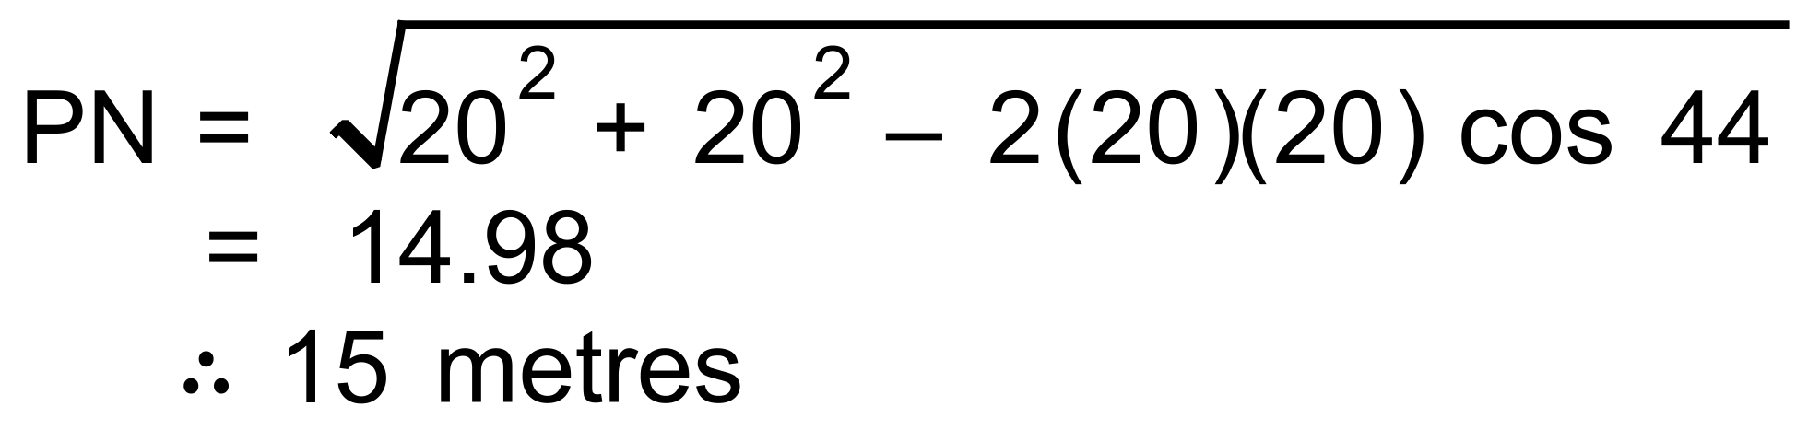 ✓✓

(b) 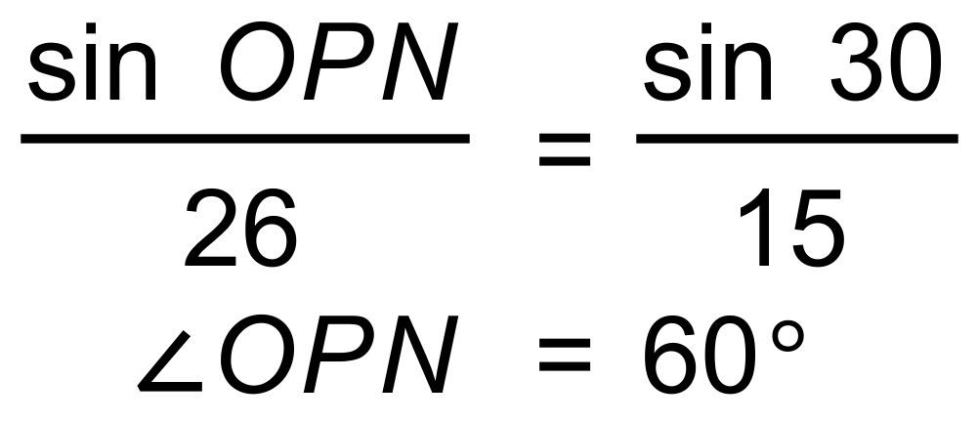 ✓

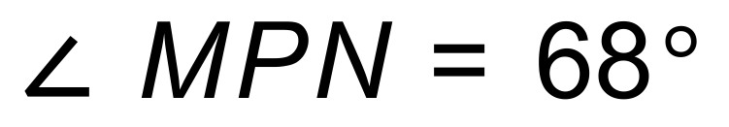since isosceles ✓

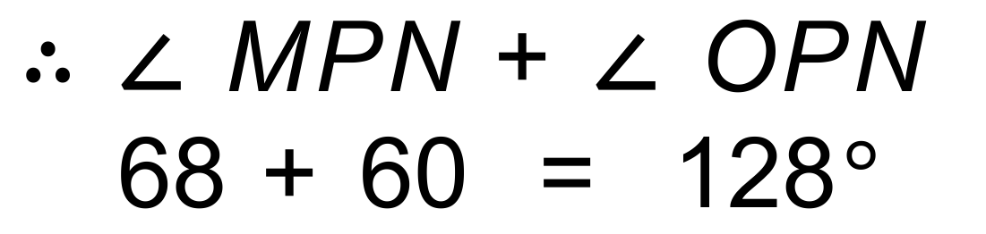 ✓

(c)  